Teenage Alcoholism
Teenage Drinking Cultures  "Underage drinking is a social activity usually undertaken by small groups of close friends, well away from the oversight of parents or other significant adults. Over time, these groups of teenage drinkers develop a range of social habits, rules and rituals that facilitate their shared alcohol consumption."  (Percy et al., 2011)  Alcohol is one of the most widely available legal drugs in the market. Binge-drinking in the UK is a social and cultural phenomenon, which is an enjoyable way of socializing and counter-balancing the demands of daily hassles and routines.  Positive and Negative Effects of Alcohol  Positive effects of drinking on young people’s health: some social and emotional coping functions of drinking that may help with a sense of positive mental well-being.  Both early initiation into drinking and heavy alcohol consumption can lead to a very wide range of adverse consequences for young people’s physical and mental health.  (Newbury-Birch, 2008, p.35)  Underage drinking risks include  - Death  - Serious injuries  - Impaired judgment − poor decisions, which can result in risky behaviour like drinking and driving, sexual activity or violence  - Increased risk for physical and sexual assault − more likely to carry out or be the victim of a physical or sexual assault.  - Brain development problems −research shows that brain development continues well into a person’s twenties. Alcohol can affect this development, and contribute to a range of problems.  (National Institute of Health, 2016a)  Alcohol use and Adolescent Pregnancy  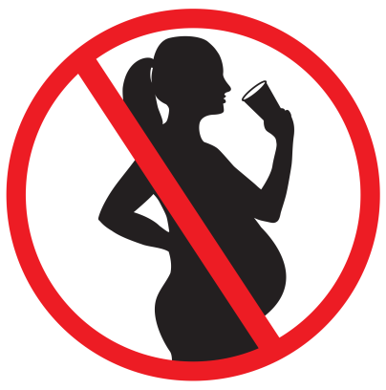  Reports indicate that many adolescents engage in heavy episodic alcohol consumption, and that they are sexually active by the age of 15 without using any form of contraception.  Combined, these activities can lead to adolescent pregnancy complicated by fetal alcohol syndrome (FAS), a rare disorder that is totally preventable by abstinence from alcohol during pregnancy.  (Allard-Hendren, 2000) | Figures (UK)  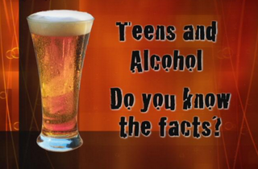  More than half (53%) of pupils thought it was OK for someone of their age to drink alcohol.  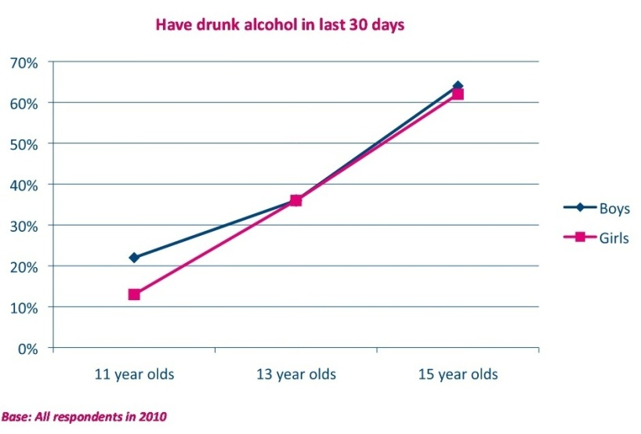  Overall, 18% of 11 year olds, 36% of 13 year olds, and 63% of 15 year olds reported having drunk some alcohol in the last 30 days.  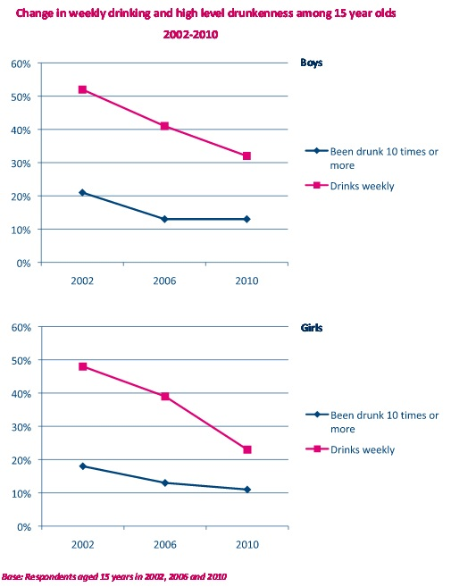  A small number of 15-year old young people (13% of boys and 11% of girls) reported a lifetime incidence of having been drunk more than 10 times. While levels of weekly drinking have decreased since 2002 and 2006, the proportion of young people that engage in a high frequency of drunkenness has not shown a corresponding decline over the same time period.  (HBSC England National Report, 2011)  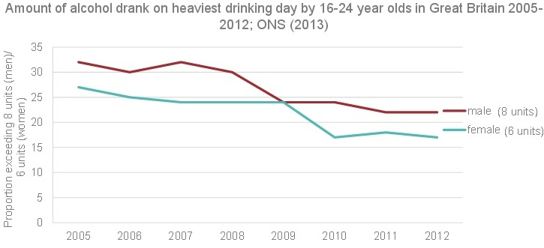  For men aged 16–24 years, the proportion drinking more than 8 units on at least one day decreased from 32% to 22% between 2005–2012 and for women drinking more than 6 units has declined from 27% to 17% over the same period, although the downward trend has flattened out in the most recent years.  (Cabinet Office, 2014) | 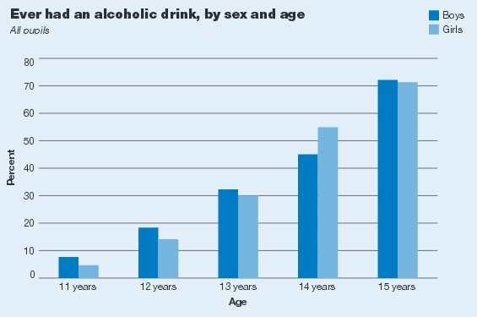  Boys and girls were equally likely to report that they had had at least one alcoholic drink in their lifetimes. The proportions increased with age, from 6% of 11 year olds to 72% of 15 year olds.  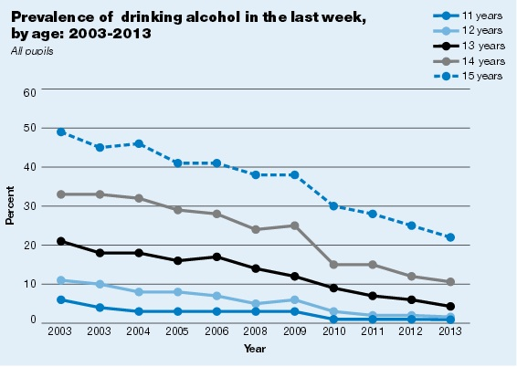  One in ten pupils (9%) aged 11 to 15 in England had drank alcohol in the last week in 2013. This continues the downward trend since 2003, when a quarter (25%) of pupils had drunk alcohol in the last week.  (Health & Social Care Information Centre, 2013)  The Adolescent Brain  There are substantial changes in the adolescent brain, which may contribute to the psychological changes in this period. Problem behaviours, like teenage drinking, may occur. Reasons:  - Strong sensation and reward-seeking tendencies  - Immature self-regulatory capabilities  (Spear, 2000, cited in Passer and Smith, 2009, p. 435)  The reward system has a nonlinear development (hypersensitive to rewards in adolescents). The prefrontal systems are implicated in impulse and inhibitory control and have a linear development.  The developing social brain also needs to be taken into account.  (Blakemore and Robbins, 2012)  The presence of peers increases adolescent risk taking by heightening sensitivity to the potential reward value of risky decisions. The presence of peers increases the activation in reward-related brain regions.  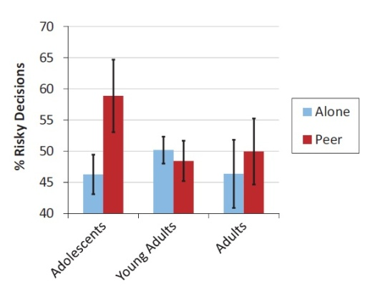  (Chein et al., 2010) | Teenage Alcoholics and Brain Functioning Abnormalities  - Abnormalities on measures of brain functioning  - Abnormalities in brain structure volume  - Abnormalities in white matter quality  - Abnormalities in activation to cognitive tasks  Even in youth with as little as 1–2 years of heavy drinking and consumption levels of 20 drinks per month, especially if >4–5 drinks are consumed on a single occasion.  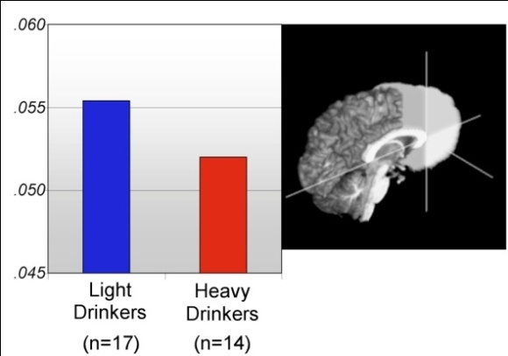  Ventral prefrontal volume (key role in decision making) in adolescents with minimal and heavy drinking histories (chart); ventral prefrontal region is highlighted in white (brain image)  (Squeglia, Jacobus and Tapert, 2009)  The effects of genes, gender, environment and culture also influence the development of the adolescent brain  (Blakemore, 2012)  Family History of Drinking: Alcoholism Genes?  Research shows that genes are partly responsible for the risk for alcoholism. The interactions between genes and environmental factors account for the risk.  (National Institute of Health, 2016b)  Drinking is NOT a Good Decision  Some skills, such as perceiving risk, considering potential consequences, generating more alternatives and developing contingency plans, appear to develop during the adolescent period. In some situations, adolescents may rely on what has been termed “experiential processing” that may result in biased decision making. Adolescent decision making about risk taking may be impacted by motivational and reasoning biases such as inappropriate decision making shortcuts, and nonoptimal decisions.  (Jacobs, 2004)  Piaget - Cognitive Development  The formal operations stage is the last stage of cognitive development (appropriate use of logic), which is achieved at the beginning of adolescence. Adolescents can perform specific operations, but they still lack some flexibility of adult operations.  (Beckett and Taylor, 2010, pp. 60-74)
Peer Pressure or Social Pressure  Studies like Milgram (1963) and Ash (1951, 1956) show that obedience to authority and conformity to group norms have a huge influence on individuals.  (cited in Eysenck, 2009, pp. 456-461)  For teenagers, it is important not to be excluded from their peer group (benefit), which can make them drink (risk) even if they do not want to.  You Shouldn’t Have to Drink! | Risk Factors of Teenage Alcoholism  As children develop, they are facing challenges and pressures in numerous aspects of their lives  - Family breakdown  - Pressure to have access to money  - The perfect body and lifestyle  - Materialist culture  - Social networking and bullying  - Early sexualisation and sexual pressures  - Violence and fear  - School expectations  - 13% of 16-24 year olds are not in employment, education or training (NEET) ────>  (Young Minds, 2016)  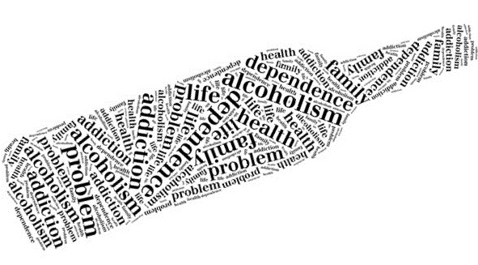 | 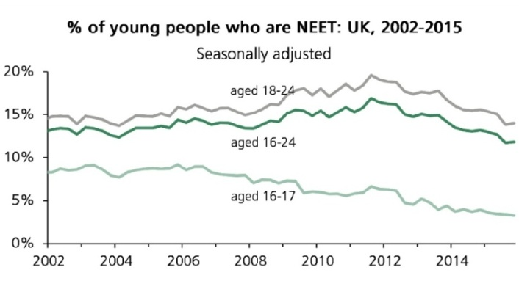  Disclosed substance abuse: 2.1 times more likely of being NEET.  (House of Commons Briefing Paper, 2016)  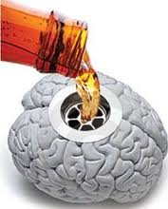 | Erikson - Stages of Development  At each psychosocial stage different crises need to be resolved, which can have a favourable or an unfavourable outcome. Unresolved issues are taken to the next stage.  (Erikson 1951, cited in Beckett and Taylor, 2010, pp. 19-59)  Unsolved issues may increase the risk of alcohol abuse (e.g. self medication)

